ALA-3
SOCIAL ENGINEERING ATTACKS
AND MAJOR SECURITY BREACHES
Five Real-World Examples: Techniques, Impact and Prevention

Introduction: Social engineering is the use of deception or psychological manipulation to persuade people to reveal confidential information, click unsafe links, transfer money, or provide access to systems. The following examples show common techniques and practical ways to reduce risk.
1. Target Data Breach (2013)
Attack technique: Phishing and third-party vendor compromise
How it happened: Attackers reportedly used credentials stolen from a third-party HVAC vendor to access Target’s network. They then moved into other parts of the network and installed malware on point-of-sale systems.
Impact: Payment-card information from about 40 million customers was affected, and personal information for up to 70 million people was also reported as exposed.
Prevention: Verify and monitor third-party access; use multi-factor authentication (MFA); separate vendor access from payment systems; monitor unusual network activity; and respond quickly to security alerts.
Key lesson: A trusted supplier can become an entry point, so third-party access must be limited and monitored.
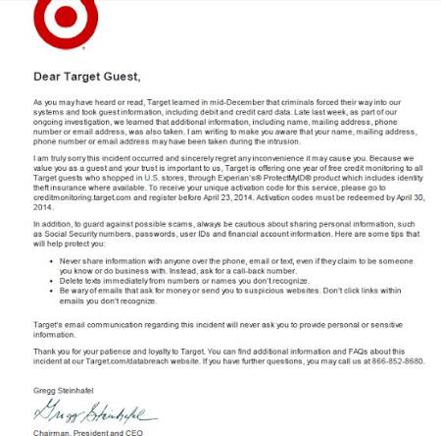

2. Yahoo Account Breaches (2013–2014; disclosed in 2016)
Attack technique: Account compromise and forged trust
How it happened: Yahoo disclosed major account breaches involving unauthorized access to user account data. Public reporting described stolen account information and, in a separate 2014 incident, attacks involving forged cookies. These incidents were not simply one phishing event, so the exact entry method varied.
Impact: Yahoo later stated that the 2013 incident affected all three billion accounts that existed at the time. The 2014 incident was initially reported as affecting at least 500 million accounts.
Prevention: Use unique passwords and MFA; protect account-recovery processes; invalidate compromised sessions; monitor suspicious logins; and notify users promptly when accounts may be affected.
Key lesson: Strong account security and fast incident response are essential when large services hold personal data.
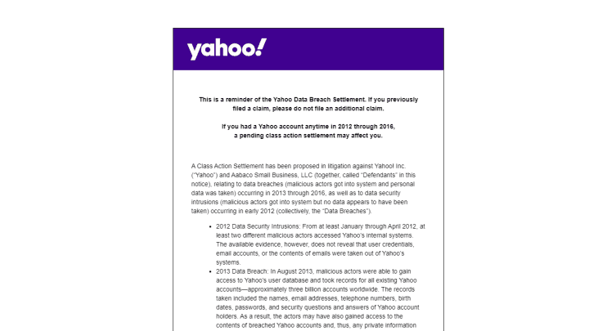

3. Facebook User Data Incident (2019)
Attack technique: Exposed credentials and unauthorized access
How it happened: In April 2019, Facebook said hundreds of millions of account passwords had been stored in a readable format inside its systems, where employees could access them. This was a security and data-handling failure rather than a classic phishing attack.
Impact: Facebook said the issue affected hundreds of millions of Facebook Lite users, tens of millions of other Facebook users, and tens of thousands of Instagram users.
Prevention: Store passwords using strong salted hashing rather than readable text; restrict employee access; audit logs and internal systems; use MFA; and follow secure data-handling practices.
Key lesson: Security depends not only on stopping attackers, but also on safely storing and restricting access to data.
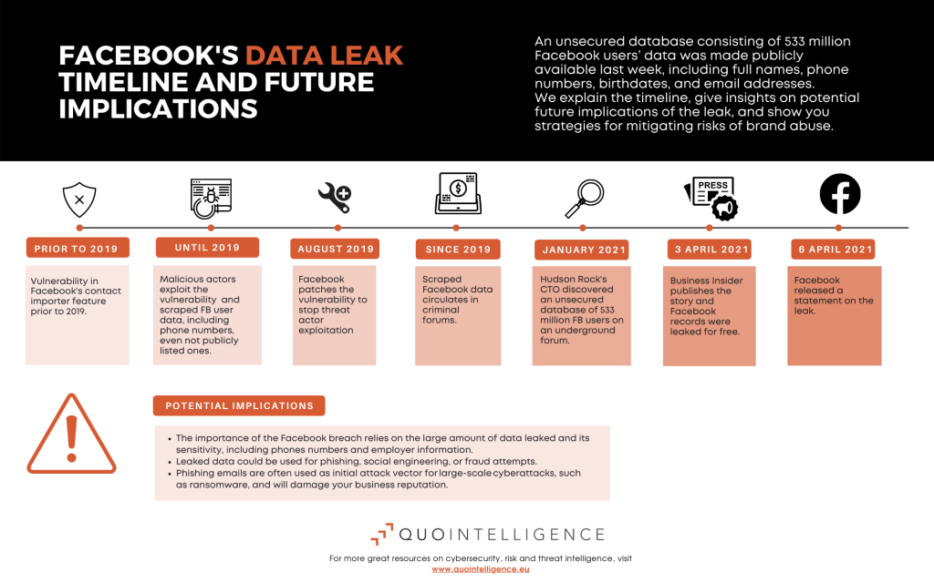
4. Google and Facebook Invoice Scam (2013–2015)
Attack technique: Pretexting and business email impersonation
How it happened: A Lithuanian man impersonated a legitimate Asian hardware supplier and sent fraudulent invoices and payment requests to employees at Google and Facebook. The requests looked like normal business transactions.
Impact: The companies collectively sent more than $100 million to accounts controlled by the fraudster before the scheme was discovered; much of the money was later recovered.
Prevention: Verify bank-detail changes through a separate trusted channel; require two-person approval for large payments; train staff to spot unusual requests; and use anti-phishing and email-authentication controls.
Key lesson: A convincing identity and familiar-looking invoice can defeat routine checks unless payment procedures are verified.
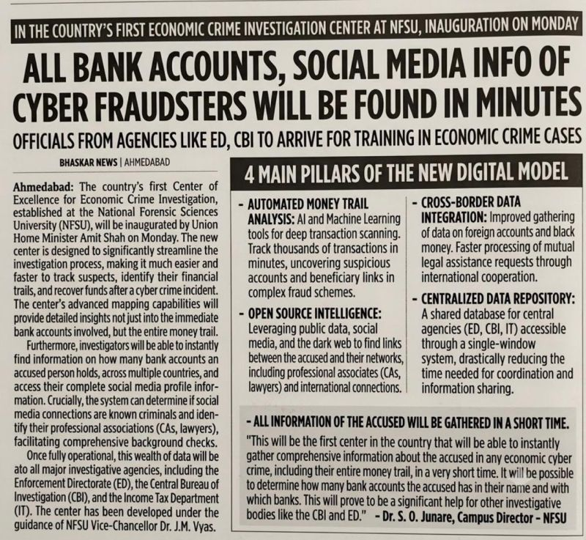
5. Twitter (now X) Social Engineering Attack (2020)
Attack technique: Phone-based social engineering and internal-tool abuse
How it happened: Attackers targeted employees using phone-based social engineering and gained access to internal tools. They used compromised access to take over high-profile accounts and post cryptocurrency scam messages.
Impact: Dozens of prominent accounts were targeted, including accounts belonging to public figures and companies. The incident damaged trust and exposed weaknesses in internal access controls.
Prevention: Train employees to verify unexpected requests; limit access to sensitive admin tools; require strong MFA; monitor privileged activity; and use approval steps for high-risk account actions.
Key lesson: Employees and administrative tools need strong protections because one compromised account can affect many users.
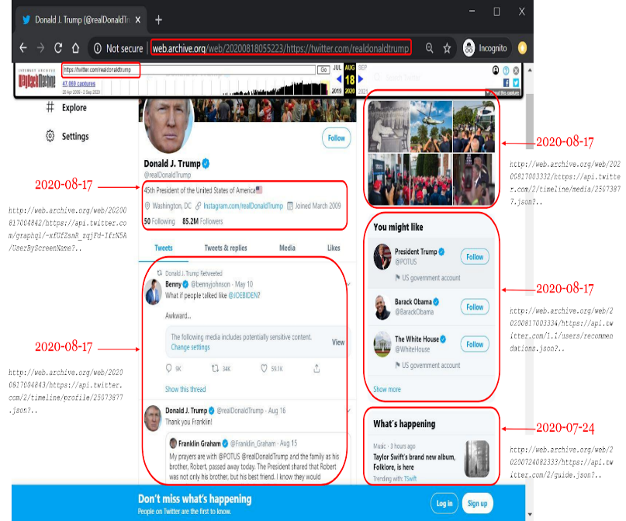
Common Social Engineering Techniques
Phishing: Fake emails, messages, or websites designed to trick people into sharing passwords or clicking malicious links.
Pretexting: Inventing a believable story or identity—for example, pretending to be IT support or a supplier—to gain trust.
Baiting: Offering something tempting, such as a free download or unknown USB drive, to encourage an unsafe action.
Business email compromise: Impersonating a manager, supplier, or business partner to request payments or sensitive information.
Phone-based social engineering: Using calls or messages to pressure a person into sharing information or granting access.
General Prevention Checklist
Pause before clicking links or opening unexpected attachments.
Verify a sender’s identity using a separate, trusted contact method.
Use unique passwords and multi-factor authentication (MFA).
Never plug in unknown USB drives or install untrusted software.
Limit access to sensitive data and administrative tools.
Keep devices, browsers, and security software updated.
Report suspicious messages or activity to the IT/security team quickly.
Conclusion
These cases show that security incidents can begin with deception, weak access controls, or unsafe data practices. Awareness training, identity verification, multi-factor authentication, limited privileges, and rapid reporting help reduce the chance and impact of an attack.
Suggested References
U.S. Senate / public reporting on the Target data breach (2013).
Yahoo security updates and breach disclosures (2016).
Meta/Facebook newsroom statement on password storage (April 2019).
U.S. Department of Justice announcement on the Google/Facebook invoice fraud case (2019).
Twitter/X public updates and U.S. Department of Justice materials regarding the 2020 attack.

